1

A)

P = Fe^{-yT}

D=T

C=T^2

B) Prove using the convexity formula

C)

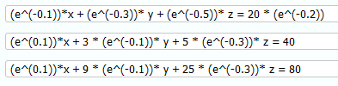

x1= 6.79, x2=16.58, x3=-3.37

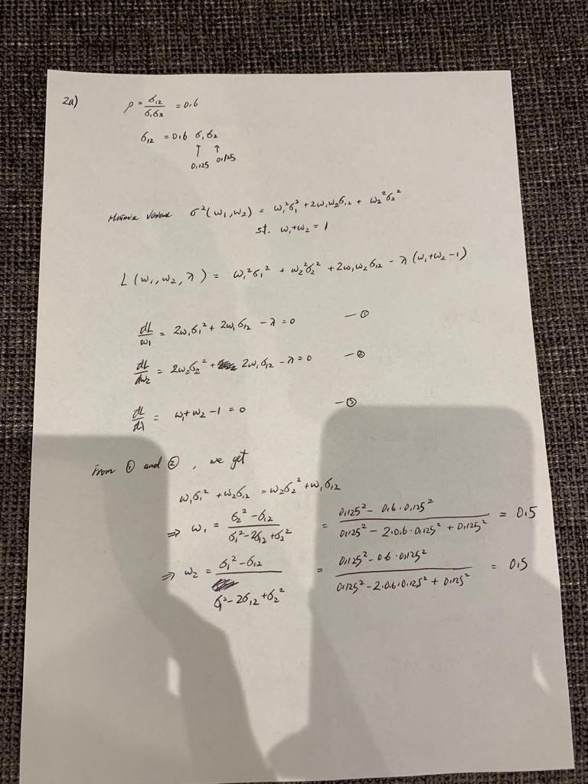

2a) What is the capital market line when no risk-free asset??

(the question is missing some info – check )

A) There is a risk-free asset. Since there is a capital market line.-.

Risk free asset was given to students during the exam is its rf = 0.05

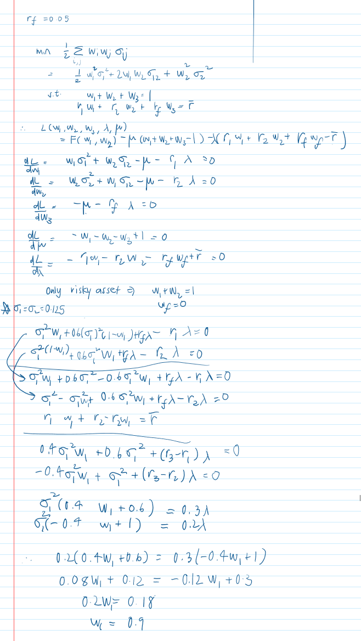

B) The market is not in equilibrium I.e. the stock prices aren’t “fair” so **the market portfolio is not efficient, so it’s not what we’re looking fo**r. We’re looking for the portfolio at the intersection of the capital market line and the curve between asset1 and asset2.

**UPDATE FROM CONOR: r_f = 0.05 is given for the risk-free asset.**

**Can confirm answer is a=0.9 as mentioned by Panos**

B) m, \sigma^2/n

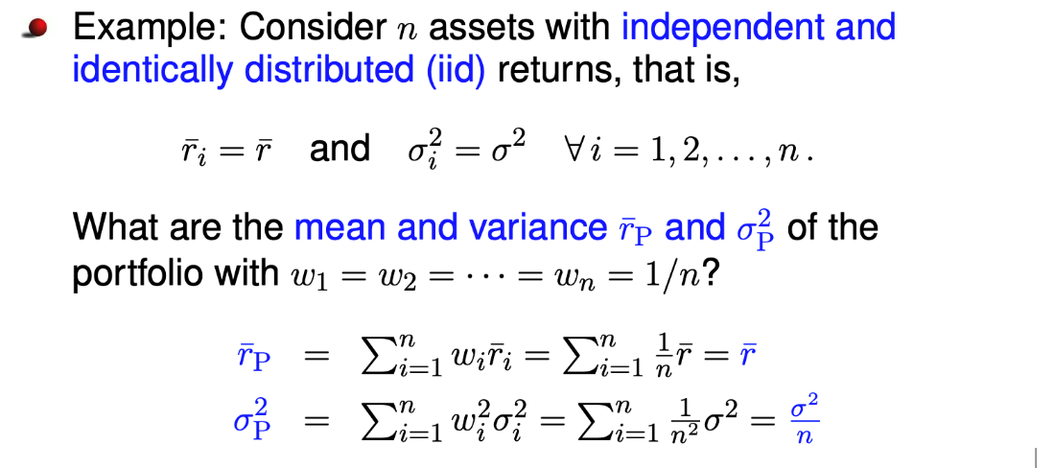

C) \sigma^2/n +0.3\sigma^2 (n-1)/n

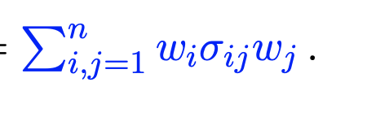;

3

A) 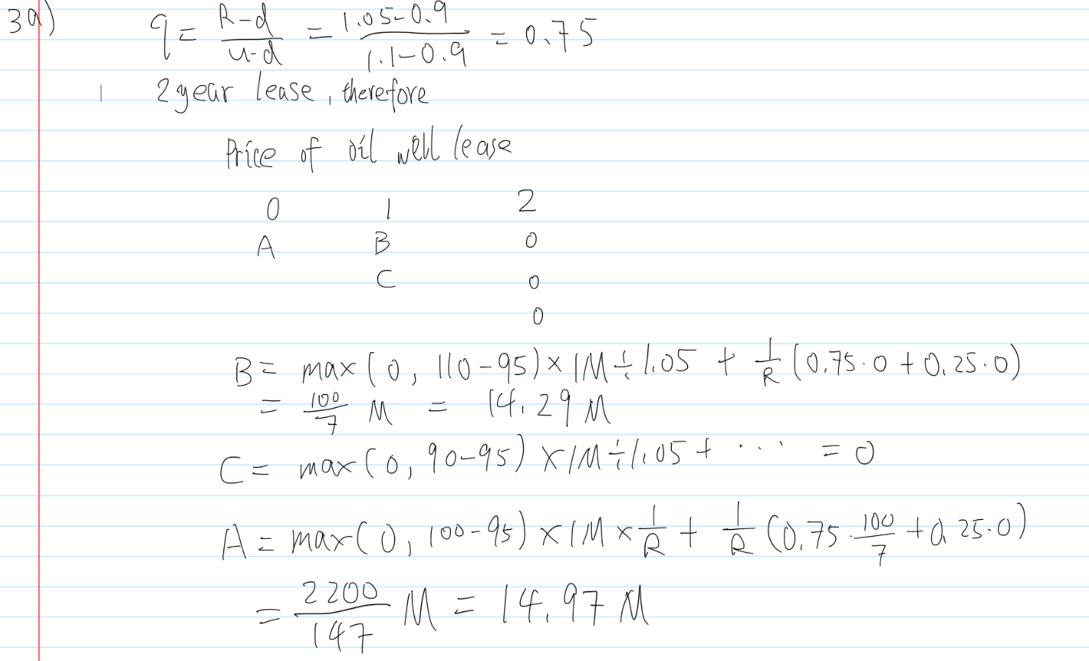

B) 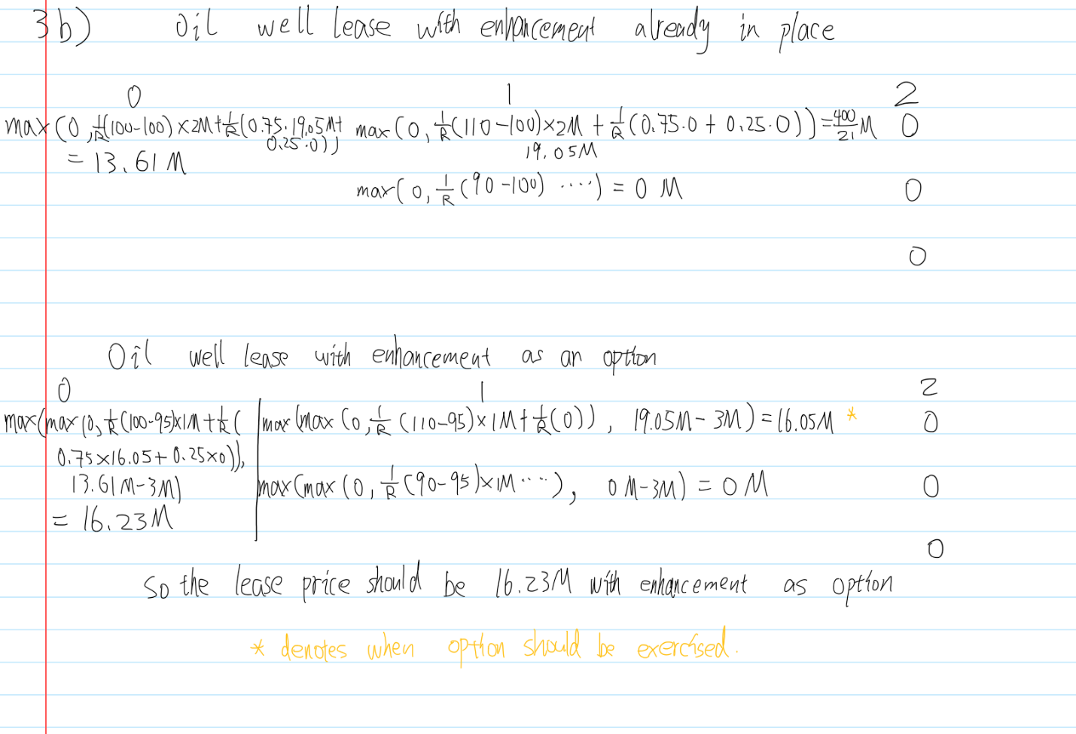

4

A) 0, see slides

B) (k-j)(dt)^(2\alpha), see slides

C) N(0, (k-j)(dt)^(2\alpha))

D) N(0, infinity) ???

Alternative D)

If alpha > 0.5, the variance of z(t_k) will be t_k * (delta t)^(2alpha), where 2alpha > 1. If dt -> 0, this will force the variance to become become 0 at a faster rate than dt ->0. Hence, z(t_k) becomes deterministic (degenerate case). Thus, we need alpha <= 0.5.

If alpha < 0.5, Var(z(t_k)) = t_k (delta t)^(2alpha), 2alpha < 1. As dt -> 0, we reach a stochastic process. Thus, dz(t) = epsilon(t)dt^(alpha), epsilon(t) ~ N(0, 1).If a = ½, we get a standard Wiener process.

D short: Normal distribution with 0 mean and variance N^(1-2\alpha), obtained from part C with k=N, j=0, dt=1/N. So, N(0, 1) if a=1/2, N(0, inf) if a<1/2, N(0, 0) if a>1/2